

# MANGALORE UNIVERSITY

ST PHILOMENA COLLEGE PUTTUR

**A PROJECT REPORT ON**

**“VENUE BOOKING SYSTEM”**

**Submitted in partial fulfilment of the requirements for the Degree of**

**Bachelor of Computer Application (BCA)**

**Mangalore University**

**By:**

**CHAITHANYA (RegNo: U05PH21S007) SINCHANA U (RegNo:U05PH21S0174)**

**Under the Guidance of**

**Mrs. Geetha Poornima K**

**Dept. Computer Science** **St Philomena College** **Darbe, Puttur.**



**Dept. of Computer Science**

**St Philomena College Philonagar**

**Darbe, Puttur D.K-574202**

**ST PHILOMENA COLLEGE, PUTTUR**

**PHILONAGAR, DARBE, PUTTUR, 574202**



**DEPT OF COMPUTER SCIENCE**

## **CERTIFICATE**

Certified that this is a bonafide record of the Mini Project Work entitled“Venue Booking System” carried out by Chaithanya(U05PH21S007) and Sinchana(U05PH21S0174) of III BCAduring the academic year 2023-24 for the partial fulfilment of the requirement to award a Bachelor of Computer Applications (BCA) Degree by Mangalore University.

**Mrs. Geetha Poornima K Mr. Vinaya Chandra**

**Project Supervisor Head of the Dept**

Forwarded to the principal for approval

**PRINCIPAL**

Submitted to the University Examination on _____________ at St Philomena College, Puttur Examination Centre

**EXAMINERS**

**Project Supervisor External**

**CERTIFICATE**

This is to certify that the Mini Project Work entitled “Venue Booking System” submitted by Chaithanya (U05PH21S0074) and Sinchana U (U05PH21S0174) has been done under my guidance and supervision during the period 2023-24 in partial fulfilment of the requirement for the award of a Bachelor of Computer application degree from Mangalore University.

To the best of my knowledge, the work and analysis mentioned in this Project Dissertation have been undertaken by the candidates themselves, and necessary references have been Recognized and acknowledged in the text of the report.

This Dissertation is the authentic record of work carried out by them and is not submitted in the past to any Institute or University

**Mrs.GeethaPoornima K**

**Department of Computer Science**

**St Philomena College**

**Darbe, Puttur.**

**Project Supervisor**

**DECLARATION**

We hereby declare that the Mini Project Work entitled “Venue Booking System” submitted to Mangalore University is a record of an original work done by us under the guidance Mrs. Geetha Poornima K of during the academic year 2023-24. This Report is submitted to the University in partial fulfilment of the requirement for the award of the Bachelor of Computer Application degree.

We hereby declare that this Dissertation is the authentic record of work carried out by us and is not submitted in the past to any Institute or University

**CHAITHANYA SINCHANA U**

**UUCMS No: U05PH21S0074** **UUCMS No: U05PH21S0174**

**ACKNOWLEDGEMENT**

We would like to sincerely thank the people who directly or indirectly helped us in completing this project without their help it would be impossible.

We express our hearty gratitude to **Rev. Dr Antony Prakash Monterio**, Principal of St Philomena College Puttur for extending all possible help to complete this project.

We thank **Mrs. Geetha Poornima K** Department of Computer Science who has guided us and provided support and genuine replies to our queries. She has not only guided us in the project but also helped by providing suggestions without which we couldn’t improve our work. Her suggestions and interest in helping us to complete our project have led us to the successful result of our project.

A special thanks to **Mr. Vinaya Chandra**, **HOD** Computer Science, for his valuable guidance. Thanks to all the Professors of the Dept. for the support. We also express our thanks to our college staff for providing the necessary information.

Our special thanks to our dear friends who provide us with their help, support, and genuine feedback that helps us improve at our best.

Finally, we thank our parents, who financially support us throughout the project and provided the support we needed throughout life. We must thank each other at the end of it.

Place: Puttur By,

Date : Chaithanya and Sinchana U

**Index**

|  |  |  |
| --- | --- | --- |
| **SL. NO** | **Table Of Content** | **Page No.** |
| **1** | **Introduction**   * 1. Introduction of the System      1. Project Title      2. Category      3. Overview      4. Background   2. Objectives of the System.   3. Scope of the System.   4. Structure of the System.   5. System Architecture   6. Software/Hardware used for the development   7. Software/Hardware required for the implementation | 1-7 |
| **2.** | **Methodology** |  |
|  | * 1. System Design      1. Functional Decomposition  1. System Software Architecture 2. System Technical Architecture 3. System Hardware Architecture 4. External Interfaces    * 1. Description of Programs 5. Context Flow Diagram (CFD) 6. Data Flow Diagrams (DFD)    1. Database Design.       1. Database Identification       2. Table Definition       3. ER Diagram    2. Detailed Design.       1. Modular decomposition of the System       2. Structure chart showing the hierarchy of modules       3. Procedural details (Flow Chart) of components | 8-40 |
| **3.** | **Analysis and Interpretation** |  |
|  | * 1. Program Code Listing   2. User Interface (Screens and Reports) | 41-64 |
|  | **Conclusion** |  |
|  | * 1. Major findings   2. Conclusion   3. Limitations   4. Major findings   5. Suggestions / recommendations   6. Learning outcomes   7. Abbreviations and Acronyms   8. References | 65-72 |

CHAPTER -1

INTRODUCTION

* 1. Introduction of the System

1.1.1 Project Title

VENUE BOOKING SYSTEM

1.1.2 Category

Web Based Relational Database Management System.

1.1.3 Overview

A venue booking system is a software application designed to manage and streamline the process of booking venues for various events such as conferences, weddings, meetings, and parties. There are three main modules: Admin, User, Service. Make it easy for users to search for available venues and make reservations. Reduce the administrative burden on venue managers by automating tasks such as invoicing, confirmations, and reminders. The system can effectively meet the needs of users and venue managers, providing a seamless booking experience.

1.1.4 Background

Introduction of the Company

The Venue Booking System project is designed to streamline the process of reserving various types of venues for events, meetings, and activities. This system caters to the needs of individuals, businesses, and organizations that require efficient management of venue bookings. The primary purpose of the Venue Booking System is to provide a centralized platform that simplifies the process of searching for, reserving, and managing venue bookings. This system aims to eliminate the manual and often cumbersome processes associated with venue reservations. Traditionally, venue bookings have been managed through manual processes such as phone calls, emails, and in-person visits. These methods are time-consuming, prone to errors, and lack real-time updates, often leading to double bookings and miscommunications.

Brief note on Existing System

The current landscape of venue booking is characterized by a mix of traditional methods and fragmented digital solutions. Despite advancements in technology, many aspects of the venue booking process remain inefficient and cumbersome, leading to various challenges for both users and venue managers.

1.2 Objective of the System

* To Workflow and Disciplined Management.
* To Catering Service.
* To save time and Simple to Use
* To Budget-Friendly.
* To choose from wide range of options

1.3 Importance and Scope of the System

1.3.1 Importance

**Perfect setting:**

Banquet halls generally keep all the vendors, caterers, and organisers in touch. The venues have access to almost all the possible things which are required for your event. For instance, if you want a Haldi-themed setting or a jungle-themed setting. Therefore, according to your requirements, the banquet hall will execute the decoration and make your dream event come true.

**Clean and well maintained:**

The most important concern in any event is the cleanliness of the hall. Imagine too many glasses of water left on the table, plates and dishes kept here and there. Therefore, a perfect event or party hall removes all your stress from an untidy environment. The banquet halls are immediately cleaned when there is such an important event. They also offer a green room, better electricity and power systems.

**Good space:**

Booking a huge or spacious party or marriage hall for your function is a privilege when it comes to the accommodation of your guests. Your grand event definitely needs a grand space, and therefore, your home is not an ideal place to celebrate it. Banquet halls have well organised seating areas, sofas, and washrooms. One of the key advantages of booking a banquet hall is having multiple washrooms.

**Hospitality and Customer Service:**

Hospitality plays a very crucial role as your guests need a positive experience throughout the event. The team at the party or event halls always tries to serve its customers with the best and provide the best experience. They take the responsibility of your event so that you can enjoy it with your guests without any tension or stress.

**Attractive decor:**

Interiors and decoration stand out as important aspects when booking any banquet hall. Because it is often said that “first impression is the last impression,” your guests are always eager to look at the banquet halls while attending the function.

1.3.2 Scope

Venue Booking Project helps in collecting perfect management in details. In a very short time, the collection will be obvious, simple and sensible. It will help a person to know the management of passed year perfectly and vividly. It also helps in current work relative to the Marriage Hall Booking System. It will also reduce the cost of collecting the management & collection procedure will go on smoothly.

* It satisfies the user requirement
* Be easy to understand by the user and operator
* Be easy to operate
* Have a good user interface
* Be expandable

* Delivered on schedule within the budget.

1.4 Structure of the System

The Venue Booking System is designed with a multi-layered architecture to ensure scalability, reliability, and user-friendliness. The system's structure includes several key components: user interface, application logic, database management, and external integrations

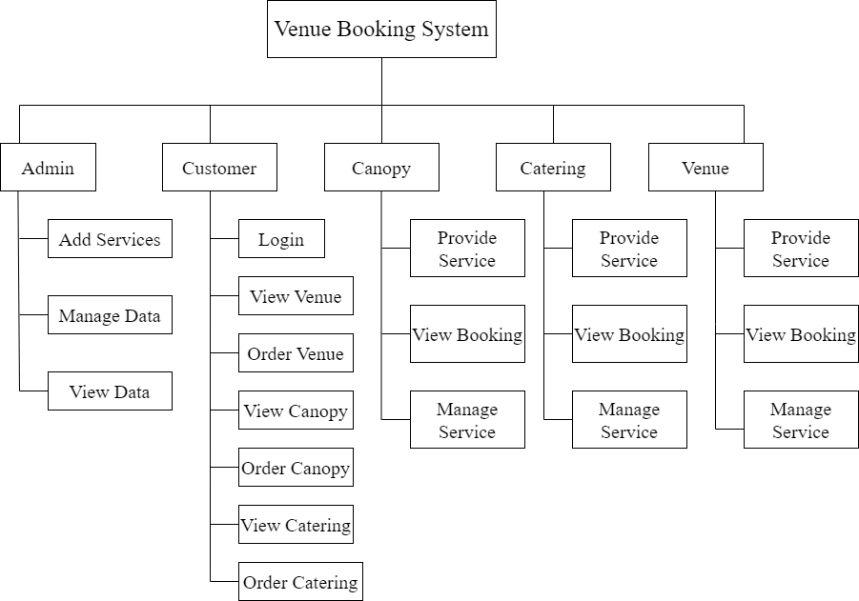

Fig 1.1: Structure Chart

1.5 System Architecture

System architecture is the conceptual model that defines the structure, behaviour, and more views of a system. An architecture description is a formal description and representation of a system, organized in a way that supports reasoning about the structure and behavior of the system.

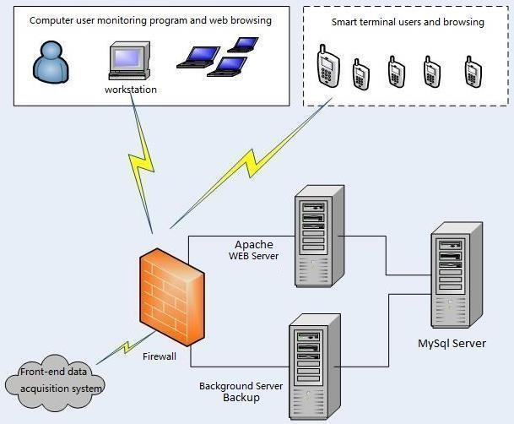

Fig 1.2: System Architecture

1.6 End Users

1.Administrator: Admin is the main person who controls the whole system. Admin will log in to the system with the credentials provided to them. His responsibility is to manage the whole application.

* Manage user accounts
* Venue and booking management
* Manage payment details

2.User: This module is specially for Customers

* User Registration and Login:
* Venue Search and Selection:
* Booking Process:

1.7 Software/Hardware used for the development

* + 1. HARDWARE INTERFACE
* RAM : 1GB or above.
* Hard disk : 10 GB or above.
* Processor : 2.4 GHZ or above.

1.7.2 SOFTWARE REQUIREMENTS

* Front end : PHP, HTML, CSS, JavaScript, Bootstrap.
* Back end : PHP
* Languages : PHP, HTML, CSS, JavaScript, Bootstrap.
* Operating system : Windows 10.
* Browser : XAMPP.

CHAPTER 2

METHODOLOGY

2.1 System Design

Systems design is the process of defining the architecture, modules, interfaces, and data for a system to satisfy specified requirements. Systems design could be seen as the application of systems theory to product development. Systems design implies a systematic approach to the design of a system. It may take a bottom-up or top-down approach, but either way the process is systematic wherein it takes into account all related variables of the system that needs to be created—from the architecture, to the required hardware and software, right down to the data and how it travels and transforms throughout its travel through the system

.

2.1.1 Functional decomposition

Functional decomposition refers broadly to the process of resolving a functional relationship into its constituent parts in such a way that the original can be reconstructed from those parts by function components. In general, this process of decomposition is undertaken either for the purpose of gaining insight into the identity of the constituent components (which may reflect individual physical process of interest) or for the purpose of obtaining a compressed representation of the global function, a task which is feasible only when the constituent processes possess a certain level of modularity (i.e., independence or non-interaction).

1. Admin Module:

* Login
* Manage Users
* Manage Canopy
* Manage Catering
* Manage data
* View data
* Add Services

2.Customer Module:

1. Register
2. Login
3. View Venue
4. Order Venue
5. View Canopy
6. Order Canopy
7. View Catering
8. Order Catering
9. View booking status

3. Canopy Module:

* Register
* Login
* Provide Service
* Manage Service
* View booking status

4.Catering Module:

1. Register
2. Login
3. Provide Service
4. Manage Service
5. View booking status

2.1.2. System Software Architecture

Software architecture refers to the fundamental structures of a software system and the discipline of creating such structures and systems. Each structure comprises software elements, relations among them, and properties of both elements and relations.

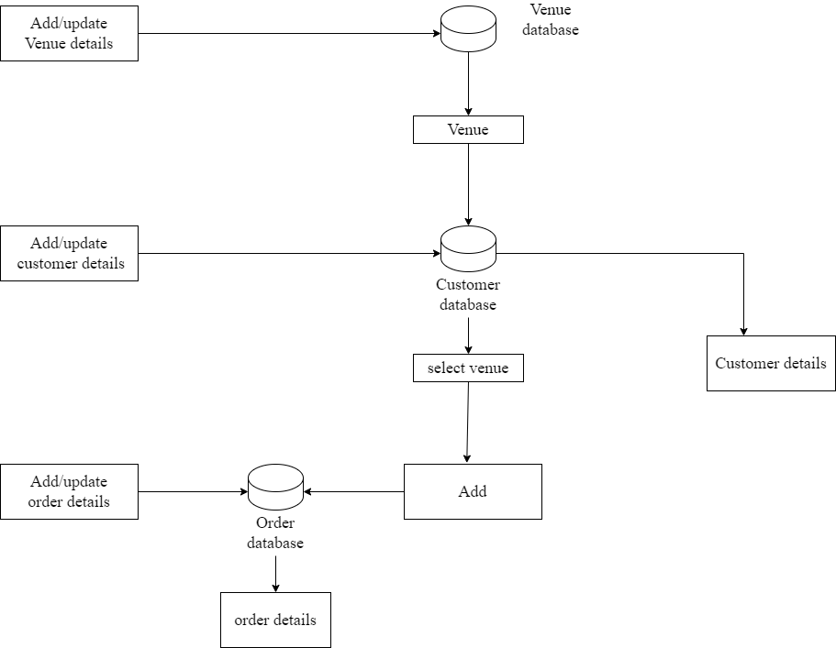

Fig 2.1: System Software Architecture

The above diagram represents System Software Architecture. It consists of 4 database tables and 7 attributes. Tables are represented as Databases in diagrams. The attributes are customers, venue, catering, canopy is handled by Admin.

2.1.3 System Technical Architecture

System technical architecture is the conceptual model that defines the structure, behaviour, and more views of a system. It serves as a blueprint for both the system and the project developing it, laying out the system's key components, their relationships, and how they interact to achieve the desired outcomes.

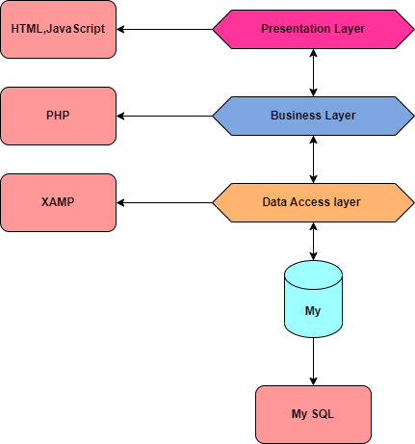

Fig 2.2: System Technical Architecture

The above diagram represents System Technical Architecture. In the First layer we have a Presentation Layer which supports HTML, CSS, JavaScript. In the Second layer we have Business Logic Layer which supports PHP and in the Third Layer we have PHP For Database Management we are using Microsoft SQL Language.

2.1.4. System Hardware Architecture

System hardware architecture refers to the design and organization of the physical components of a computer system. It encompasses the layout, structure, and interconnections of various hardware elements that form the basis of a computing system. The architecture outlines how these components work together to perform computing tasks efficiently and reliably.

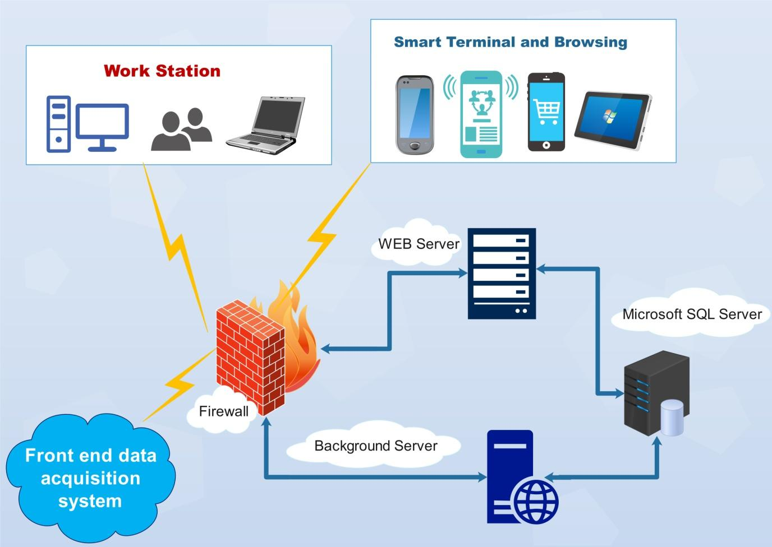

Fig 2.3: System Hardware Architecture

Above diagram represents System Hardware Architecture. It comprises Servers, Firewall, Workstations and Smart Terminals. For the database server we use Microsoft SQL Server, for the web server our project is supported for Google chrome, Mozilla Firefox, internet explorer Microsoft edge etc. Firewalls are the part of web servers for protection. Then we have workstations and terminals.

External interface

* Name of application: Venue Booking System.
* Details of interface: Admin panel, Customer Panel, Canopy Panel Catering Panel.
* Type of interface: Graphical User Interface.

2.2 Description of the Programs

Data Flow Diagram is a graphical representation of a system or a portion of the system. It consists of data flow, process, sources and sink and stores all the description using easily understandable symbols. DFD is one of the most important modeling tools. It is used to model the system, components that interact with the system, uses the data and information flows in the system. DFD shows the information moves through the and how it is modified by a series of transformations. It is a graphical technique that depicts information moves from input or output. DFD is also known as bubble chart or Data Flows Graphs. DFD may be used to represent the system at any level of abstraction.

2.2.1 Context Flow Diagram (CFD)

Context flow diagram is a top level (also known as level 0) data flow diagram. It contains only one process node that generalizes the functions of the entire system in relationship to external entities. In context diagram the entire system is treated as a single process and all its inputs, outputs, sinks and sources are identified and shown below.

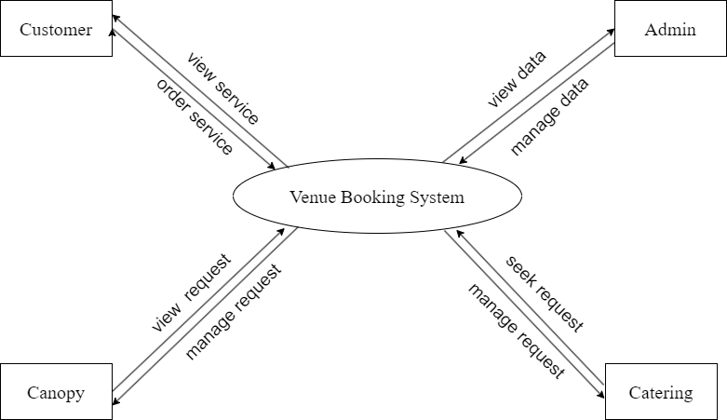

Fig 2.4: Context Flow Diagram (CFD)

The above diagram is context flow diagram. It consists of 4 attributes they are: Admin, Customer, Canopy, Catering.

2.2.2 Data Flow Diagram

Data Flow Diagram is a graphical representation of a system or a portion of the system. It consists of data flow, process, sources and sink and stores all the description using easily understandable symbols. DFD is one of the most important modelling tools. It is used to model the system, components that interact with the system, uses the data and information flows in the system. DFD shows the information moves through the and how it is modified by a series of transformations. It is a graphical technique that depicts information moves from input or output. DFD is also known as bubble chart or Data Flows Graphs. DFD may be used to represent the system at any level of abstraction.

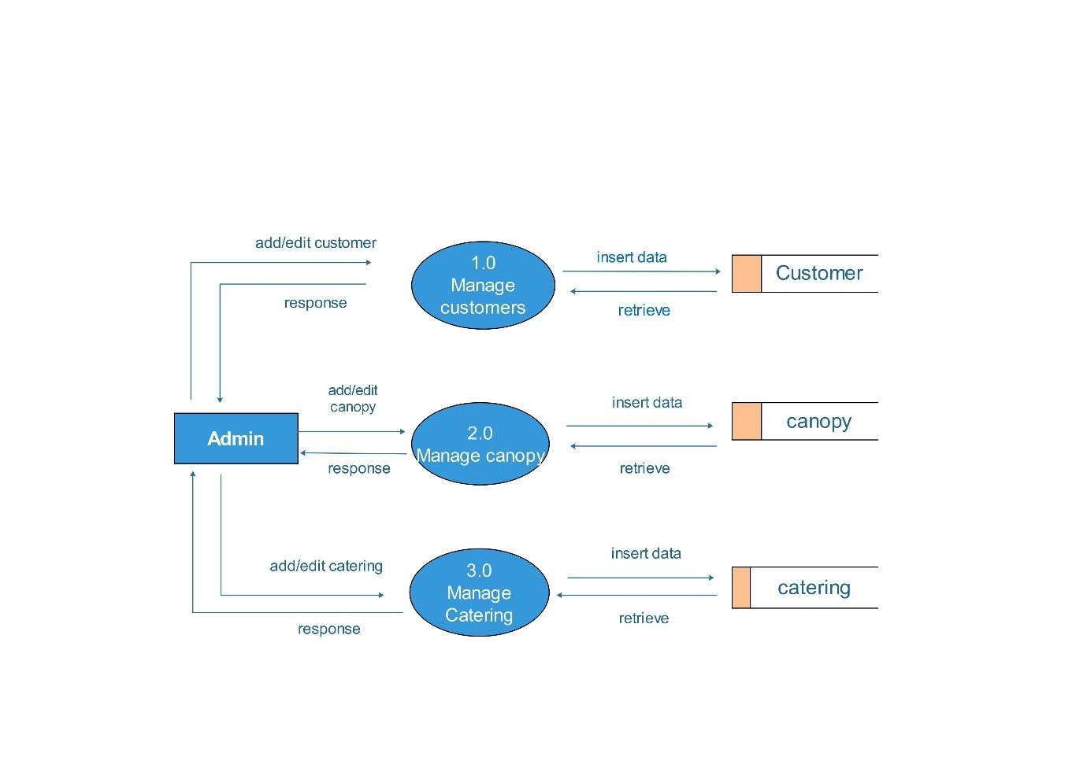

Fig 2.5: Data Flow Diagram (DFD)

The DFD represents the overall admin module and its interactions with external entities:

* Customers
* Canopy
* Catering
* Admin Module: The main process/system for admin tasks.
* Database: Stores venue information, booking records, and user accounts.

## 2.3 Database Design

### 2.3.1 Database Identification

* + - * Admin
      * User
      * Venue
      * Canopy
      * Catering

### 2.3.2 Table Definition

A table definition is the blueprint that sets the structure. It defines:

* + - * Table Name: Unique identifier for the data set.
      * Columns: Data points (e.g., name, age) with data types (text, number).
      * Constraints: Rules like primary keys (unique row identifiers) for data integrity.

#### Admin Table

|  |  |  |  |
| --- | --- | --- | --- |
| Attributes | Data Types | Size | Description |
| ID | INTEGER | 10 | This is used to store id. |
| Name | VARCHAR | 45 | This is the name of the admin |
| Contact Number | VARCHAR | 10 | This is used to store contact numbers. |
| E-mail | VARCHAR | 45 | This is used to store the email |
| Password | INTEGER | 9 | This is used to store admin password |

**Customer Table**

|  |  |  |  |
| --- | --- | --- | --- |
| Attributes | Data Types | Size | Description |
| ID | INTEGER | 9 | This is used to store customer ID |
| Name | VARCHAR | 45 | This is the name of the customer |
| Contact Number | VARCHAR | 10 | This is used to store contact numbers. |
| E-mail | VARCHAR | 45 | This is used to store the email |
| Address | VARCHAR | 45 | This is used to store the address of the customer |

**Venue Table**

|  |  |  |  |
| --- | --- | --- | --- |
| Attributes | Data Types | Size | Description |
| Venue_ID | INTEGER | 9 | This is used to store Venue ID. |
| Name | VARCHAR | 45 | This is the Venue name. |
| Contact Number | VARCHAR | 10 | This is used to store contact numbers. |
| Capacity | VARCHAR | 500 | This is used to store the capacity. |
| Adress | VARCHAR | 45 | This is used to store the address. |
| Location | VARCHAR | 15 | This stores Location of the venue. |

**Canopy Table**

|  |  |  |  |
| --- | --- | --- | --- |
| Attributes | Data Types | Size | Description |
| ID | INTEGER | 9 | This is used to store Canopy Id. |
| Provider | VARCHAR | 45 | This is the name of the provider. |
| Contact Number | VARCHAR | 10 | This is used to store contact numbers. |
| Facility_ID | INTEGER | 9 | This is used to store the Facility Id. |

**Catering Table**

|  |  |  |  |
| --- | --- | --- | --- |
| Attributes | Data Types | Size | Description |
| ID | INTEGER | 9 | This is used to store Catering Id. |
| Provider | VARCHAR | 45 | This stores name of the provider. |
| Contact Number | VARCHAR | 10 | This is used to store contact numbers. |
| Location | INTEGER | 9 | This is used to store the Location. |

### 2.3.3 ER Diagram

Entity relationship diagram is used in modern database software engineering to illustrate logical structure of database. It is a relational schema database modelling method used to model a system and approach. This approach is commonly used in database design. The diagram created using this method is called the E-R diagram.

* Entity:

Entity is represented by a box within the ER Diagram. Entities are abstract concepts, each representing one or more instances of the concept in question. An entity might be considered.

* Relationship:

Relationships are represented by Diamonds. A relationship is a named collection or association between entities or used to relate to two or more entities with some common attributes or meaningful interaction between the objects.

* Attribute:

Attributes are represented by Oval. An attribute is a single data item related to a database object. The database schema associates one or more attributes with each database entity.

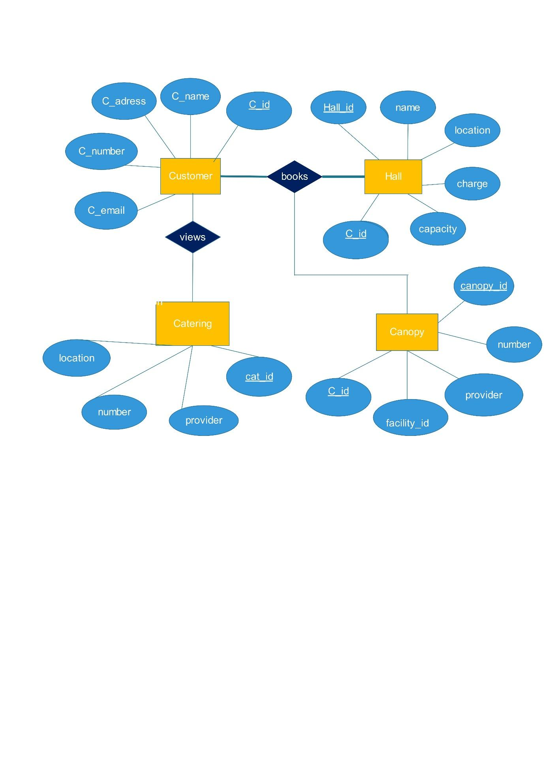

Fig 2.6:**ER Diagram**

## 2.4 Detailed Design

Detailed Design the process of refining and expanding the preliminary design of a system or component to the extent that the design is sufficiently complete to begin implementation. Detailed design starts after the system design phase and system has been certified through the review. The goal of this phase is to develop the internal logic of each of the modules identified during system design. In the system design, the focus is on identifying the modules, whereas during detailed design the focus is on designing the logic for the modules

### 2.4.1 Modular Decomposition of the System

### Functional Component 1: Admin

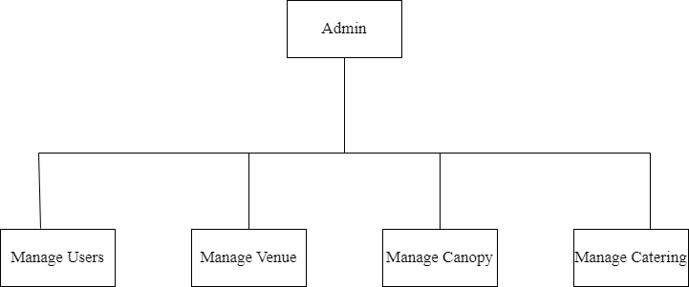

Fig 2.3

### Functional Component 2: User

### 

Fig 2.4

### Functional Component 4: Canopy

### 

Fig 2.5

### Functional Component 5:Catering

### 

Fig 2.6

2.3.2 Structure chart showing the hierarchy of module

A structure chart is a graphical representation of the hierarchical relationship among the modules in a software system. It helps in understanding how the system is divided into various functional components and how these components interact with each other.

a. Structure chart of Admin

### 

Fig 2.7: Structure chart of admin

b. Structure chart of User

### Fig 2.8: Structure chart of user

c. Structure chart of Venue

### 

Fig 2.9: Structure chart of venue

d.Structure chart of Canopy

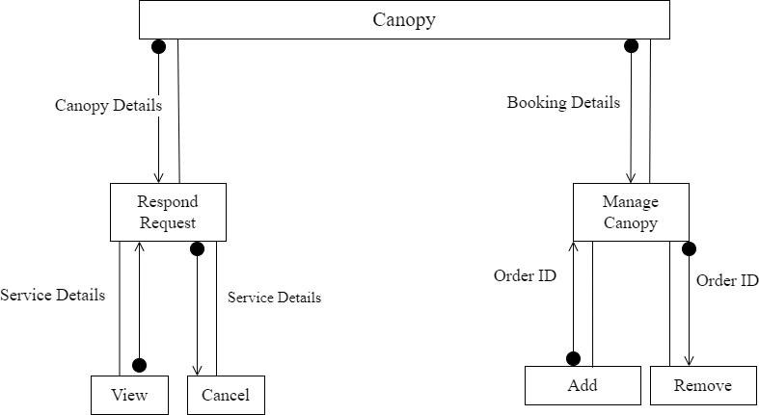

Fig 2.10: Structure chart of canopy

e..Structure chart of Catering

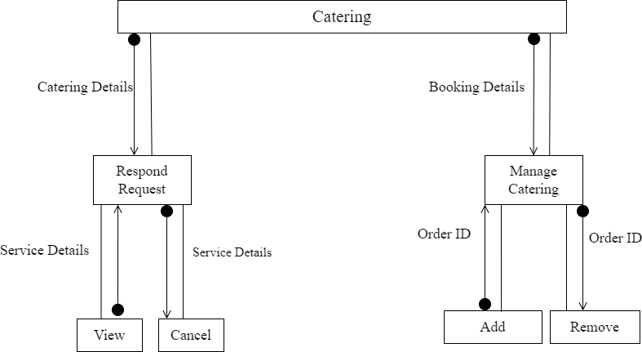

Fig 2.11: Structure chart of catering

2.4.1.1 Admin Login

1.Input**s:** Username, Password

2.Database I/O interfaces: Admin table.

3.Outputs: Entered Username and password will be checked for validity if it is valid, Admin will be redirected to Homepage.

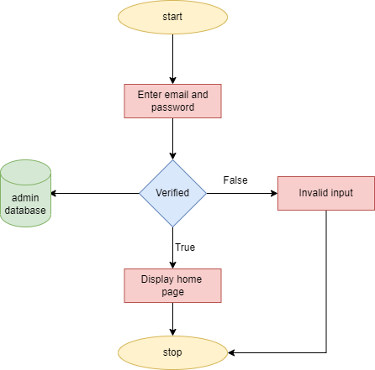

Fig 8: Procedural details of Admin Login

2.4.1.1 Admi Views User

1.Inputs: Username

2.Database I/O Interfaces: User table

3.Outputs: Admin can view user details.

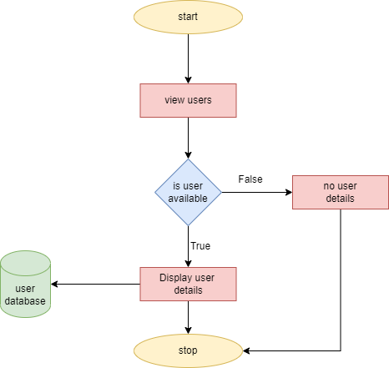

Fig 8.1: Procedural details of Admin Views User

2.4.1.2 Admin adds Venue

1.Inputs: Username

2.Procedural Details

(Flow Chart):

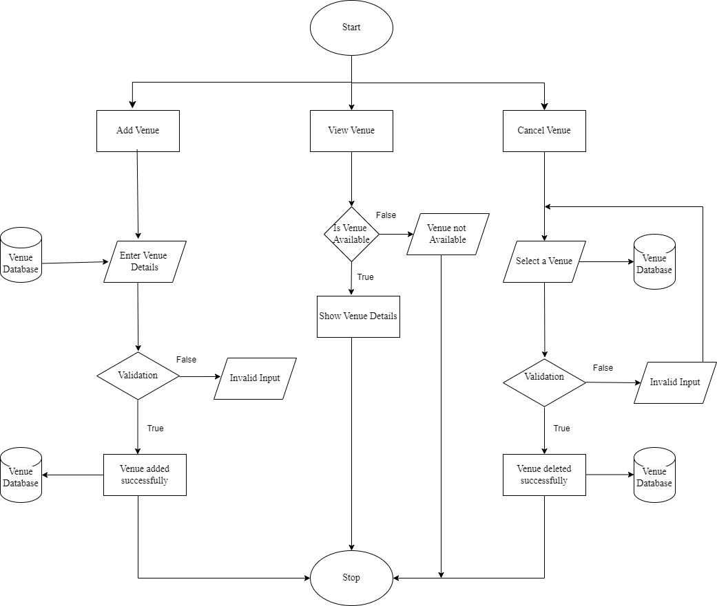

Fig 8.2: Procedural details of Admin adds Venue

2.4.1.3 Admin adds Canopy

1.Inputs: Username

2.Procedural Details

(Flow Chart):

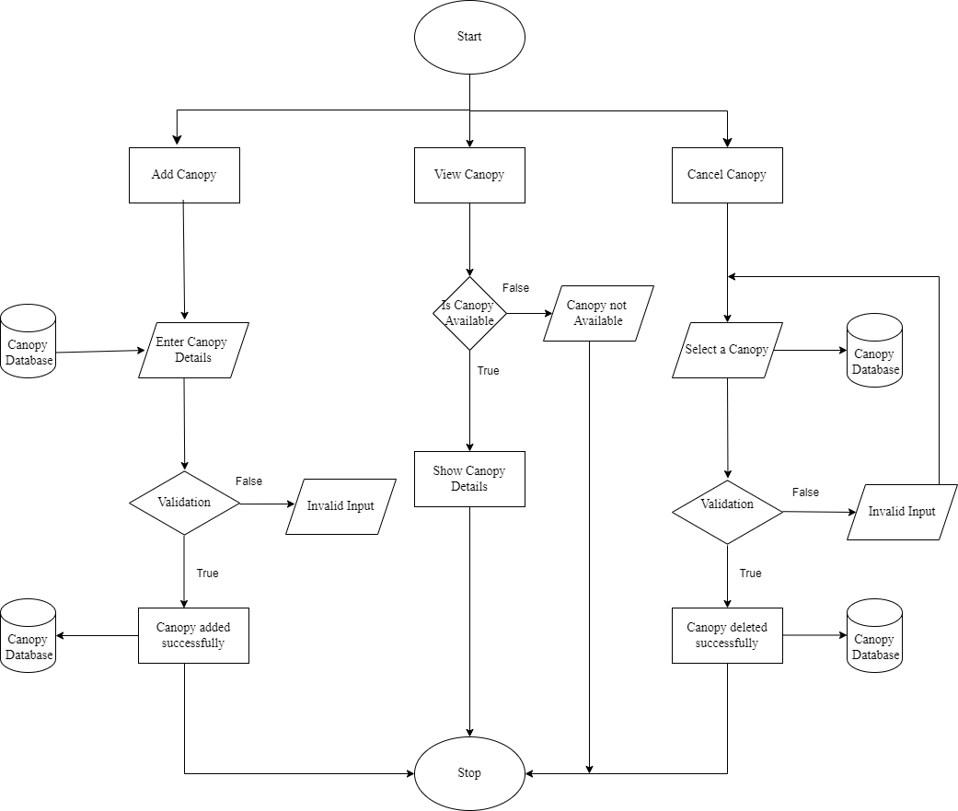

Fig : Procedural details of Admin adds Canopy

2.4.1.4 Admin adds Catering

1.Inputs: Username

2.Procedural Details

(Flow Chart):

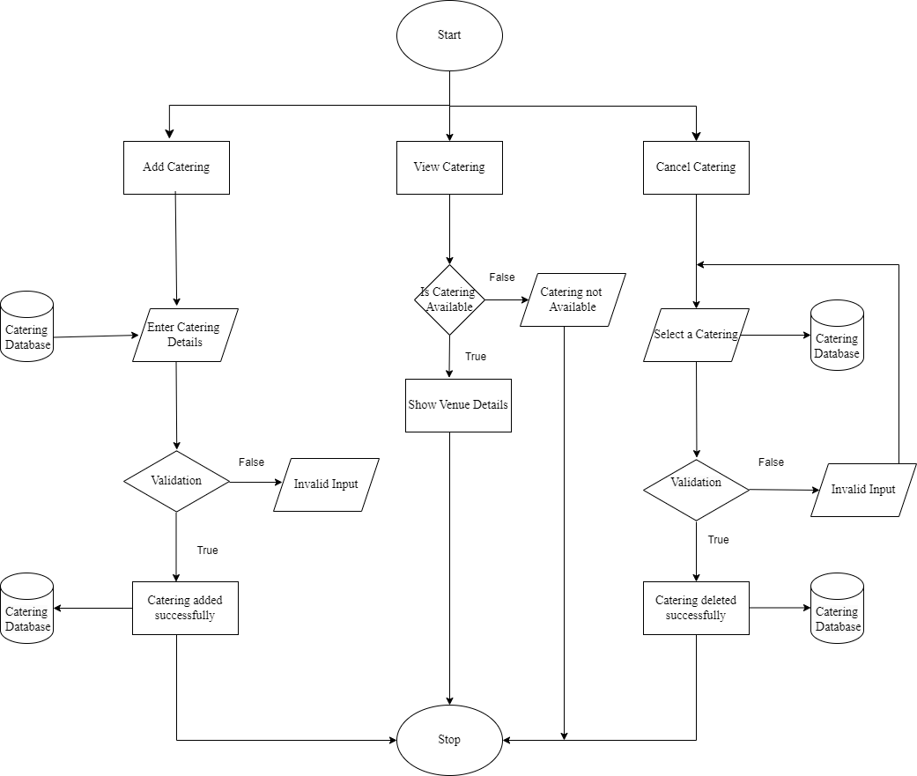

Fig : Procedural details of Admin adds Catering

2.4.1.5 Customer registration

1.Inputs: Username, Password

2.Procedural Details

(Flow Chart):

Entered details will be checked for validity if it is valid customer will be register on database.

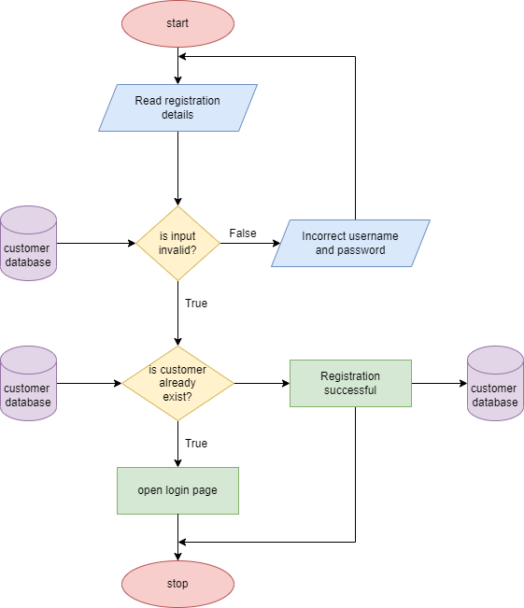

Fig: Procedural details of Customer registration

2.4.1.6 Customer Login

1.Inputs: Username, Password

2.Procedural Details

3.Database I/O Interfaces: System has interface to login credentials.

4.Output:Entered Username and password will be checked for validity if it is valid, Customer will be redirected to Homepage

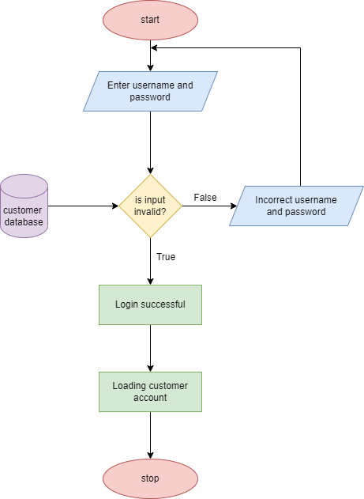

Fig : Procedural details of Customer Login

###### 2.4.1.7 Customer order Services

1.Inputs: Service details

2.Procedural Details

3.Database I/O Interfaces: System has interface to displays service details.

4.Output: Order data stored in the database.

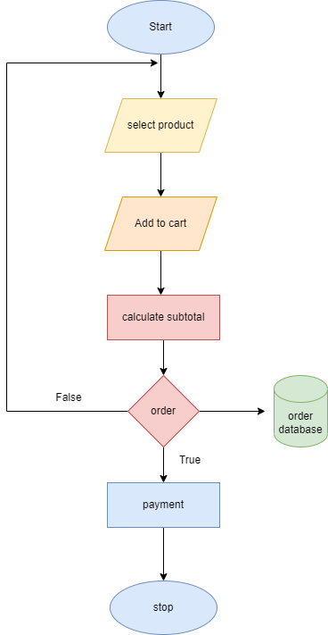

Fig : Procedural details of Customer order Services

.

CHAPTER 3

ANALYSIS AND INTERPRETATION

3.Program code listing

3.1 Database Connection

Admin Login Confirmation

&lt;?php

include(&#39;../action.php&#39;);

?&gt;

&lt;!DOCTYPE html&gt;

&lt;html lang=&quot;en&quot;&gt;

&lt;head&gt;

&lt;meta charset=&quot;UTF-8&quot;&gt;

&lt;meta name=&quot;viewport&quot; content=&quot;width=device-width, initial-scale=1.0&quot;&gt;

&lt;meta http-equiv=&quot;X-UA-Compatible&quot; content=&quot;ie=edge&quot;&gt;

&lt;title&gt;Log In Form&lt;/title&gt;

&lt;!-- Font Icon --&gt;

&lt;link rel=&quot;stylesheet&quot; href=&quot;fonts/material-icon/css/material-design-iconic-

font.min.css&quot;&gt;

&lt;!-- Main css --&gt;

&lt;link rel=&quot;stylesheet&quot; href=&quot;css/style.css&quot;&gt;

&lt;/head&gt;

&lt;body&gt;

&lt;div class=&quot;main&quot;&gt;

&lt;section class=&quot;signup&quot;&gt;

&lt;div class=&quot;container&quot;&gt;

&lt;div class=&quot;signup-content&quot;&gt;

&lt;form method=&quot;POST&quot; id=&quot;signup-form&quot; class=&quot;signup-form&quot;&gt;

&lt;h2 class=&quot;form-title&quot;&gt;Admin Log In&lt;/h2&gt;

&lt;div class=&quot;form-group&quot;&gt;

&lt;input type=&quot;text&quot; class=&quot;form-input&quot; name=&quot;name&quot; id=&quot;name&quot;

placeholder=&quot;Your Name&quot;/&gt;

&lt;/div&gt;

&lt;div class=&quot;form-group&quot;&gt;

&lt;input type=&quot;password&quot; class=&quot;form-input&quot; name=&quot;psw&quot;

id=&quot;password&quot; placeholder=&quot;Password&quot;/&gt;

&lt;span toggle=&quot;#password&quot; class=&quot;zmdi zmdi-eye field-icon

toggle-password&quot;&gt;&lt;/span&gt;

&lt;/div&gt;

&lt;div class=&quot;form-group&quot;&gt;

&lt;input type=&quot;submit&quot; name=&quot;admin&quot; id=&quot;submit&quot; class=&quot;form-

submit&quot; value=&quot;Login Now&quot;/&gt;

&lt;/div&gt;

&lt;/form&gt;

&lt;/div&gt;

&lt;/div&gt;

&lt;/section&gt;

&lt;/div&gt;

&lt;!-- JS --&gt;

&lt;script src=&quot;vendor/jquery/jquery.min.js&quot;&gt;&lt;/script&gt;

&lt;script src=&quot;js/main.js&quot;&gt;&lt;/script&gt;

&lt;/body&gt;

&lt;/html&gt;

Registration Confirmation

&lt;?php

include(&#39;../action.php&#39;);

if (!isset($_SESSION[&#39;uid&#39;])) {

header(&#39;location:../index.php&#39;);

}

?&gt;

&lt;!DOCTYPE html&gt;

&lt;html lang=&quot;en&quot;&gt;

&lt;head&gt;

&lt;meta charset=&quot;UTF-8&quot;&gt;

&lt;meta name=&quot;viewport&quot; content=&quot;width=device-width, initial-scale=1.0&quot;&gt;

&lt;meta http-equiv=&quot;X-UA-Compatible&quot; content=&quot;ie=edge&quot;&gt;

&lt;title&gt;Wedding Registration&lt;/title&gt;

&lt;!-- Font Icon --&gt;

&lt;link rel=&quot;stylesheet&quot; href=&quot;fonts/material-icon/css/material-design-iconic-

font.min.css&quot;&gt;

&lt;!-- Main css --&gt;

&lt;link rel=&quot;stylesheet&quot; href=&quot;css/style.css&quot;&gt;

&lt;/head&gt;

&lt;body&gt;

&lt;div class=&quot;main&quot;&gt;

&lt;section class=&quot;signup&quot;&gt;

&lt;div class=&quot;container&quot;&gt;

&lt;div class=&quot;signup-content&quot;&gt;

&lt;form method=&quot;POST&quot; id=&quot;signup-form&quot; class=&quot;signup-form&quot;&gt;

&lt;h2 class=&quot;form-title&quot;&gt;Registration&lt;/h2&gt;

&lt;div class=&quot;form-group&quot;&gt;

&lt;input type=&quot;text&quot; class=&quot;form-input&quot; name=&quot;name&quot; id=&quot;name&quot;

placeholder=&quot;Your Name&quot; required /&gt;

&lt;/div&gt;

&lt;div class=&quot;form-group&quot;&gt;

&lt;input type=&quot;text&quot; class=&quot;form-input&quot; name=&quot;dname&quot; id=&quot;name&quot;

placeholder=&quot;Groom Name&quot; required/&gt;

&lt;/div&gt;

&lt;div class=&quot;form-group&quot;&gt;

&lt;input type=&quot;text&quot; class=&quot;form-input&quot; name=&quot;dlname&quot; id=&quot;name&quot;

placeholder=&quot;Bride Name&quot; required/&gt;

&lt;/div&gt;

&lt;div class=&quot;form-group&quot;&gt;

&lt;input type=&quot;text&quot; class=&quot;form-input&quot; name=&quot;pno&quot; id=&quot;name&quot;

placeholder=&quot;Number of person&quot; required/&gt;

&lt;/div&gt;

&lt;div class=&quot;form-group&quot;&gt;

&lt;h3 class=&quot;form-input&quot;&gt; Wedding Date: &amp;nbsp &amp;nbsp&lt;input

type=&quot;date&quot; name=&quot;date&quot; id=&quot;name&quot; required/&gt;&lt;/h3&gt;

&lt;/div&gt;

&lt;div class=&quot;form-group&quot;&gt;

&lt;input type=&quot;checkbox&quot; name=&quot;agree-term&quot; id=&quot;agree-term&quot;

class=&quot;agree-term&quot; /&gt;

&lt;label for=&quot;agree-term&quot; class=&quot;label-agree-

term&quot;&gt;&lt;span&gt;&lt;span&gt;&lt;/span&gt;&lt;/span&gt;I agree all statements in &lt;a href=&quot;#&quot; class=&quot;term-

service&quot;&gt;Terms of service&lt;/a&gt;&lt;/label&gt;

&lt;/div&gt;

&lt;div class=&quot;form-group&quot;&gt;

&lt;input type=&quot;submit&quot; name=&quot;submit&quot; id=&quot;submit&quot; class=&quot;form-submit&quot;

value=&quot;Submit&quot;/&gt;

&lt;/div&gt;

&lt;/form&gt;

&lt;/div&gt;

&lt;/div&gt;

&lt;/section&gt;

&lt;/div&gt;

&lt;!-- JS --&gt;

&lt;script src=&quot;vendor/jquery/jquery.min.js&quot;&gt;&lt;/script&gt;

&lt;script src=&quot;js/main.js&quot;&gt;&lt;/script&gt;

&lt;/body&gt;

&lt;/html&gt;

Signup Confirmation

&lt;?php

include(&#39;../action.php&#39;);

?&gt;

&lt;!DOCTYPE html&gt;

&lt;html lang=&quot;en&quot;&gt;

&lt;head&gt;

&lt;meta charset=&quot;UTF-8&quot;&gt;

&lt;meta name=&quot;viewport&quot; content=&quot;width=device-width, initial-scale=1.0&quot;&gt;

&lt;meta http-equiv=&quot;X-UA-Compatible&quot; content=&quot;ie=edge&quot;&gt;

&lt;title&gt;Sign Up Form&lt;/title&gt;

&lt;!-- Font Icon --&gt;

&lt;link rel=&quot;stylesheet&quot; href=&quot;fonts/material-icon/css/material-design-iconic-

font.min.css&quot;&gt;

&lt;!-- Main css --&gt;

&lt;link rel=&quot;stylesheet&quot; href=&quot;css/style.css&quot;&gt;

&lt;/head&gt;

&lt;body&gt;

&lt;div class=&quot;main&quot;&gt;

&lt;section class=&quot;signup&quot;&gt;

&lt;div class=&quot;container&quot;&gt;

&lt;div class=&quot;signup-content&quot;&gt;

&lt;form method=&quot;POST&quot; id=&quot;signup-form&quot; class=&quot;signup-form&quot;&gt;

&lt;h2 class=&quot;form-title&quot;&gt;Create account&lt;/h2&gt;

&lt;div class=&quot;form-group&quot;&gt;

&lt;input type=&quot;text&quot; class=&quot;form-input&quot; name=&quot;name&quot; id=&quot;name&quot;

placeholder=&quot;Your Name&quot; required /&gt;

&lt;/div&gt;

&lt;div class=&quot;form-group&quot;&gt;

&lt;input type=&quot;text&quot; class=&quot;form-input&quot; name=&quot;uname&quot; id=&quot;name&quot;

placeholder=&quot;Username&quot; required/&gt;

&lt;/div&gt;

&lt;div class=&quot;form-group&quot;&gt;

&lt;input type=&quot;email&quot; class=&quot;form-input&quot; name=&quot;email&quot; id=&quot;email&quot;

placeholder=&quot;Your Email &quot;required/&gt;

&lt;/div&gt;

&lt;div class=&quot;form-group&quot;&gt;

&lt;input type=&quot;text&quot; class=&quot;form-input&quot; name=&quot;pno&quot; id=&quot;date&quot;

placeholder=&quot;Phone No.&quot;required/&gt;

&lt;/div&gt;

&lt;div class=&quot;form-group&quot;&gt;

&lt;input type=&quot;text&quot; class=&quot;form-input&quot; name=&quot;add&quot; id=&quot;date&quot;

placeholder=&quot;Address :&quot;required/&gt;

&lt;/div&gt;

&lt;div class=&quot;form-group&quot;&gt;

&lt;input type=&quot;password&quot; class=&quot;form-input&quot; name=&quot;psw&quot;

id=&quot;password&quot; placeholder=&quot;Password&quot;required/&gt;

&lt;span toggle=&quot;#password&quot; class=&quot;zmdi zmdi-eye field-icon toggle-

password&quot;&gt;&lt;/span&gt;

&lt;/div&gt;

&lt;div class=&quot;form-group&quot;&gt;

&lt;input type=&quot;password&quot; class=&quot;form-input&quot; name=&quot;repsw&quot;

id=&quot;re_password&quot; placeholder=&quot;Repeat your password&quot; required/&gt;

&lt;/div&gt;

&lt;div class=&quot;form-group&quot;&gt;

&lt;input type=&quot;submit&quot; name=&quot;signup&quot; id=&quot;submit&quot; class=&quot;form-submit&quot;

value=&quot;Sign up&quot;/&gt;

&lt;/div&gt;

&lt;/form&gt;

&lt;p class=&quot;loginhere&quot;&gt;

Have already an account ? &lt;a href=&quot;login.php&quot; class=&quot;loginhere-

link&quot;&gt;Login here&lt;/a&gt;

&lt;/p&gt;

&lt;/div&gt;

&lt;/div&gt;

&lt;/section&gt;

&lt;/div&gt;

&lt;!-- JS --&gt;

&lt;script src=&quot;vendor/jquery/jquery.min.js&quot;&gt;&lt;/script&gt;

&lt;script src=&quot;js/main.js&quot;&gt;&lt;/script&gt;

&lt;/body&gt;

&lt;/html&gt;

Venue Booking

&lt;?php

include(&#39;../action.php&#39;);

if (!isset($_SESSION[&#39;name&#39;])) {

header(&#39;location:../index.php&#39;);

}

?&gt;

&lt;!DOCTYPE html&gt;

&lt;html lang=&quot;en&quot;&gt;

&lt;head&gt;

&lt;meta charset=&quot;UTF-8&quot;&gt;

&lt;meta name=&quot;viewport&quot; content=&quot;width=device-width, initial-scale=1.0&quot;&gt;

&lt;meta http-equiv=&quot;X-UA-Compatible&quot; content=&quot;ie=edge&quot;&gt;

&lt;title&gt;Features Details&lt;/title&gt;

&lt;!-- Font Icon --&gt;

&lt;link rel=&quot;stylesheet&quot; href=&quot;fonts/material-icon/css/material-design-iconic-

font.min.css&quot;&gt;

&lt;!-- Main css --&gt;

&lt;link rel=&quot;stylesheet&quot; href=&quot;css/style.css&quot;&gt;

&lt;/head&gt;

&lt;body&gt;

&lt;div class=&quot;main&quot;&gt;

&lt;section class=&quot;signup&quot;&gt;

&lt;div class=&quot;container&quot;&gt;

&lt;div class=&quot;signup-content&quot;&gt;

&lt;form method=&quot;POST&quot; id=&quot;signup-form&quot; class=&quot;signup-form&quot;&gt;

&lt;h2 class=&quot;form-title&quot;&gt;Venue Details&lt;/h2&gt;

&lt;div class=&quot;form-group&quot;&gt;

&lt;input type=&quot;text&quot; class=&quot;form-input&quot; name=&quot;vname&quot;

id=&quot;name&quot; placeholder=&quot;Venue Name&quot;/&gt;

&lt;/div&gt;

&lt;div class=&quot;form-group&quot;&gt;

&lt;input type=&quot;text&quot; class=&quot;form-input&quot; name=&quot;price&quot;

id=&quot;email&quot; placeholder=&quot;Price&quot;/&gt;

&lt;/div&gt;

&lt;div class=&quot;form-group&quot;&gt;

&lt;input type=&quot;text&quot; class=&quot;form-input&quot; name=&quot;desc&quot;

id=&quot;date&quot; placeholder=&quot;Description &quot;/&gt;

&lt;/div&gt;

&lt;div class=&quot;form-group&quot;&gt;

&lt;input type=&quot;submit&quot; name=&quot;venue&quot; id=&quot;submit&quot;

class=&quot;form-submit&quot; value=&quot;Submit&quot;/&gt;

&lt;/div&gt;

&lt;/form&gt;

&lt;/div&gt;

&lt;/div&gt;

&lt;/section&gt;

&lt;/div&gt;

&lt;!-- JS --&gt;

&lt;script src=&quot;vendor/jquery/jquery.min.js&quot;&gt;&lt;/script&gt;

&lt;script src=&quot;js/main.js&quot;&gt;&lt;/script&gt;

&lt;/body&gt;

&lt;/html&gt;

Catering Booking

&lt;?php

include(&#39;../action.php&#39;);

if (!isset($_SESSION[&#39;name&#39;])) {

header(&#39;location:../index.php&#39;);

}

?&gt;

&lt;!DOCTYPE html&gt;

&lt;html lang=&quot;en&quot;&gt;

&lt;head&gt;

&lt;meta charset=&quot;UTF-8&quot;&gt;

&lt;meta name=&quot;viewport&quot; content=&quot;width=device-width, initial-scale=1.0&quot;&gt;

&lt;meta http-equiv=&quot;X-UA-Compatible&quot; content=&quot;ie=edge&quot;&gt;

&lt;title&gt;Features Details&lt;/title&gt;

&lt;!-- Font Icon --&gt;

&lt;link rel=&quot;stylesheet&quot; href=&quot;fonts/material-icon/css/material-design-iconic-

font.min.css&quot;&gt;

&lt;!-- Main css --&gt;

&lt;link rel=&quot;stylesheet&quot; href=&quot;css/style.css&quot;&gt;

&lt;/head&gt;

&lt;body&gt;

&lt;div class=&quot;main&quot;&gt;

&lt;section class=&quot;signup&quot;&gt;

&lt;div class=&quot;container&quot;&gt;

&lt;div class=&quot;signup-content&quot;&gt;

&lt;form method=&quot;POST&quot; id=&quot;signup-form&quot; class=&quot;signup-form&quot;&gt;

&lt;h2 class=&quot;form-title&quot;&gt;Catering Details&lt;/h2&gt;

&lt;div class=&quot;form-group&quot;&gt;

&lt;input type=&quot;text&quot; class=&quot;form-input&quot; name=&quot;vname&quot;

id=&quot;name&quot; placeholder=&quot;Venue Name&quot;/&gt;

&lt;/div&gt;

&lt;div class=&quot;form-group&quot;&gt;

&lt;input type=&quot;text&quot; class=&quot;form-input&quot; name=&quot;price&quot;

id=&quot;email&quot; placeholder=&quot;Price&quot;/&gt;

&lt;/div&gt;

&lt;div class=&quot;form-group&quot;&gt;

&lt;input type=&quot;text&quot; class=&quot;form-input&quot; name=&quot;desc&quot;

id=&quot;date&quot; placeholder=&quot;Description &quot;/&gt;

&lt;/div&gt;

&lt;div class=&quot;form-group&quot;&gt;

&lt;input type=&quot;submit&quot; name=&quot;cat&quot; id=&quot;submit&quot; class=&quot;form-

submit&quot; value=&quot;Submit&quot;/&gt;

&lt;/div&gt;

&lt;/form&gt;

&lt;/div&gt;

&lt;/div&gt;

&lt;/section&gt;

&lt;/div&gt;

&lt;!-- JS --&gt;

&lt;script src=&quot;vendor/jquery/jquery.min.js&quot;&gt;&lt;/script&gt;

&lt;script src=&quot;js/main.js&quot;&gt;&lt;/script&gt;

&lt;/body&gt;

&lt;/html&gt;

3.1.2 Canopy Booking

&lt;?php

include(&#39;../action.php&#39;);

if (!isset($_SESSION[&#39;name&#39;])) {

header(&#39;location:../index.php&#39;);

}

?&gt;

&lt;!DOCTYPE html&gt;

&lt;html lang=&quot;en&quot;&gt;

&lt;head&gt;

&lt;meta charset=&quot;UTF-8&quot;&gt;

&lt;meta name=&quot;viewport&quot; content=&quot;width=device-width, initial-scale=1.0&quot;&gt;

&lt;meta http-equiv=&quot;X-UA-Compatible&quot; content=&quot;ie=edge&quot;&gt;

&lt;title&gt;Features Details&lt;/title&gt;

&lt;!-- Font Icon --&gt;

&lt;link rel=&quot;stylesheet&quot; href=&quot;fonts/material-icon/css/material-design-iconic-

font.min.css&quot;&gt;

&lt;!-- Main css --&gt;

&lt;link rel=&quot;stylesheet&quot; href=&quot;css/style.css&quot;&gt;

&lt;/head&gt;

&lt;body&gt;

&lt;div class=&quot;main&quot;&gt;

&lt;section class=&quot;signup&quot;&gt;

&lt;div class=&quot;container&quot;&gt;

&lt;div class=&quot;signup-content&quot;&gt;

&lt;form method=&quot;POST&quot; id=&quot;signup-form&quot; class=&quot;signup-form&quot;&gt;

&lt;h2 class=&quot;form-title&quot;&gt;Canopy Details&lt;/h2&gt;

&lt;div class=&quot;form-group&quot;&gt;

&lt;input type=&quot;text&quot; class=&quot;form-input&quot; name=&quot;vname&quot;

id=&quot;name&quot; placeholder=&quot;Venue Name&quot;/&gt;

&lt;/div&gt;

&lt;div class=&quot;form-group&quot;&gt;

&lt;input type=&quot;text&quot; class=&quot;form-input&quot; name=&quot;price&quot;

id=&quot;email&quot; placeholder=&quot;Price&quot;/&gt;

&lt;/div&gt;

&lt;div class=&quot;form-group&quot;&gt;

&lt;input type=&quot;text&quot; class=&quot;form-input&quot; name=&quot;desc&quot;

id=&quot;date&quot; placeholder=&quot;Description &quot;/&gt;

&lt;/div&gt;

&lt;div class=&quot;form-group&quot;&gt;

&lt;input type=&quot;submit&quot; name=&quot;dect&quot; id=&quot;submit&quot; class=&quot;form-

submit&quot; value=&quot;Submit&quot;/&gt;

&lt;/div&gt;

&lt;/form&gt;

&lt;/div&gt;

&lt;/div&gt;

&lt;/section&gt;

&lt;/div&gt;

&lt;!-- JS --&gt;

&lt;script src=&quot;vendor/jquery/jquery.min.js&quot;&gt;&lt;/script&gt;

&lt;script src=&quot;js/main.js&quot;&gt;&lt;/script&gt;

&lt;/body&gt;

&lt;/html&gt;

3.1.3Logout Code

&lt;?php

session_start();

unset($_SESSION[&#39;uid&#39;]);

unset($_SESSION[&#39;uname&#39;]);

unset($_SESSION[&#39;name&#39;]);

header(&#39;location:../index.php&#39;);

?&gt;

3.2 User Interface

3.2.1 Home Page

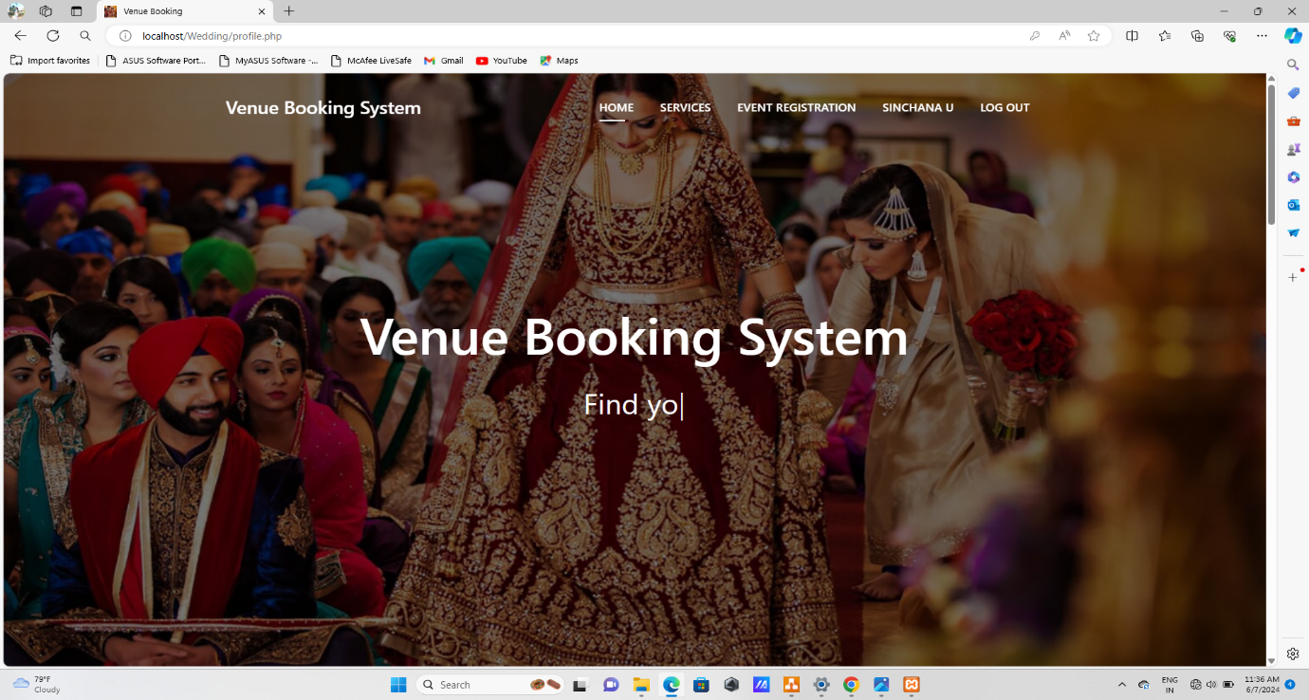

Fig 3.1

3.2.2 Page to Create an Account

Users can create an account by providing the necessary details.

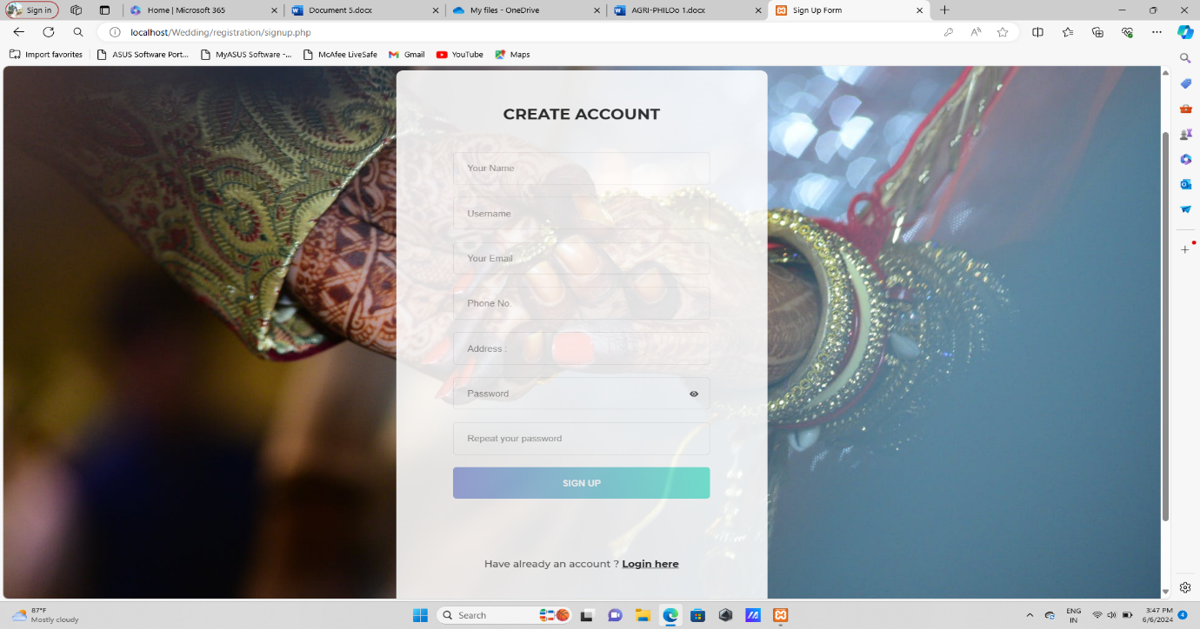

Fig 3.2

3.2.3 User Login Page

This is the User Login Page for Users. By entering the login username and password the user can login to the system.

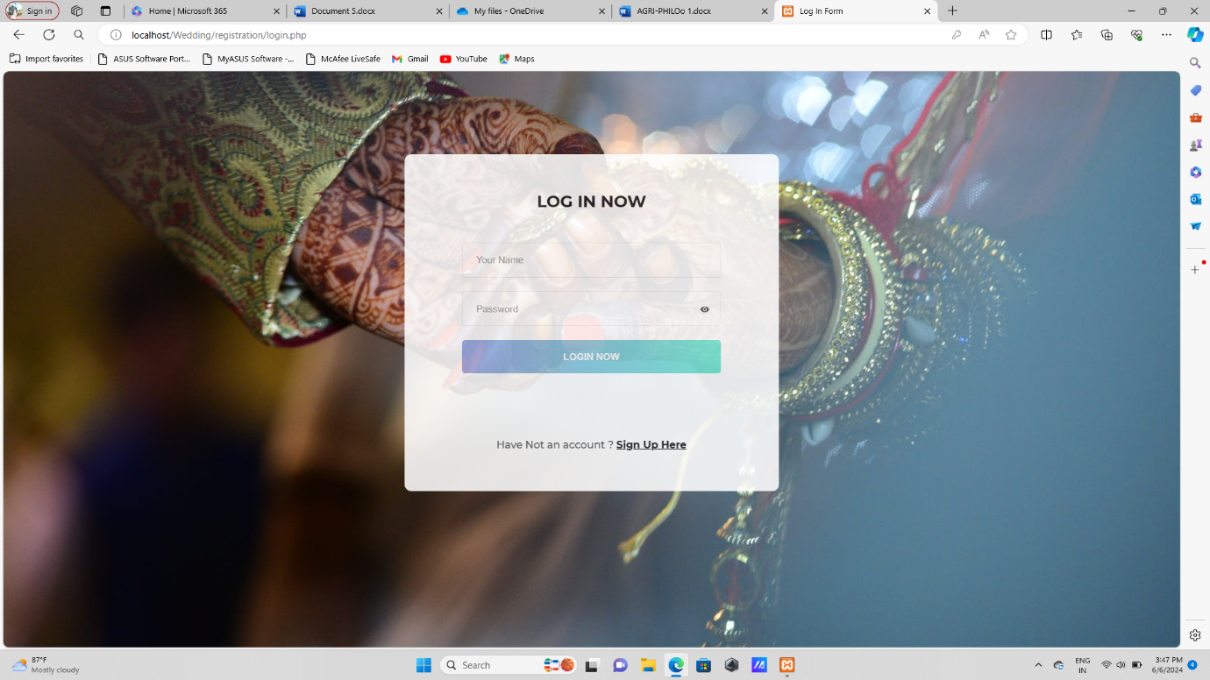

Fig 3.3

3.2.4 Page to Select the Services

Users can select the services for their events.

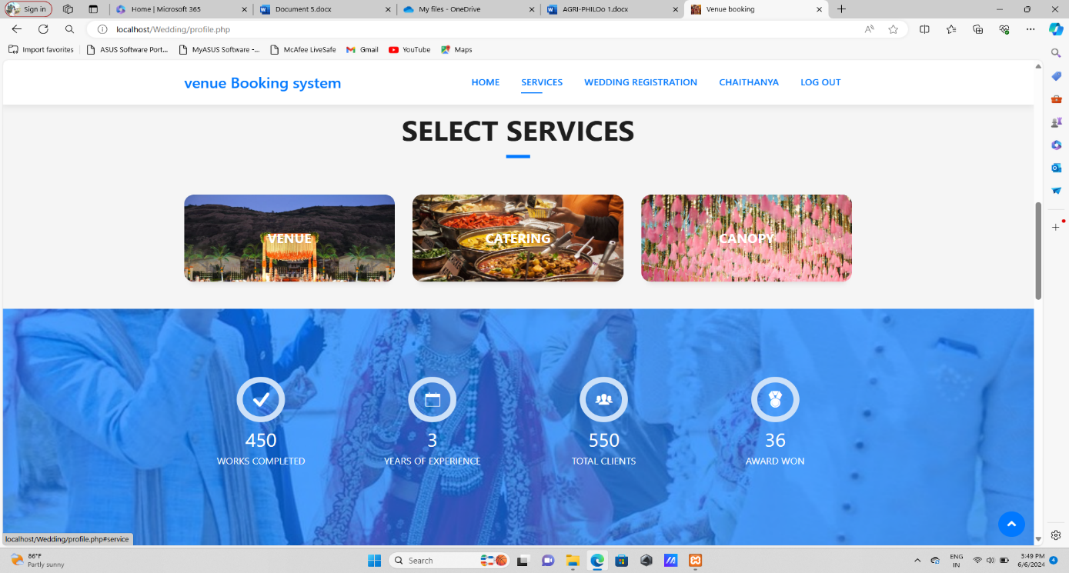

Fig 3.4

3.2.5 Event Details

After adding all the services users can view the details with the total amount.

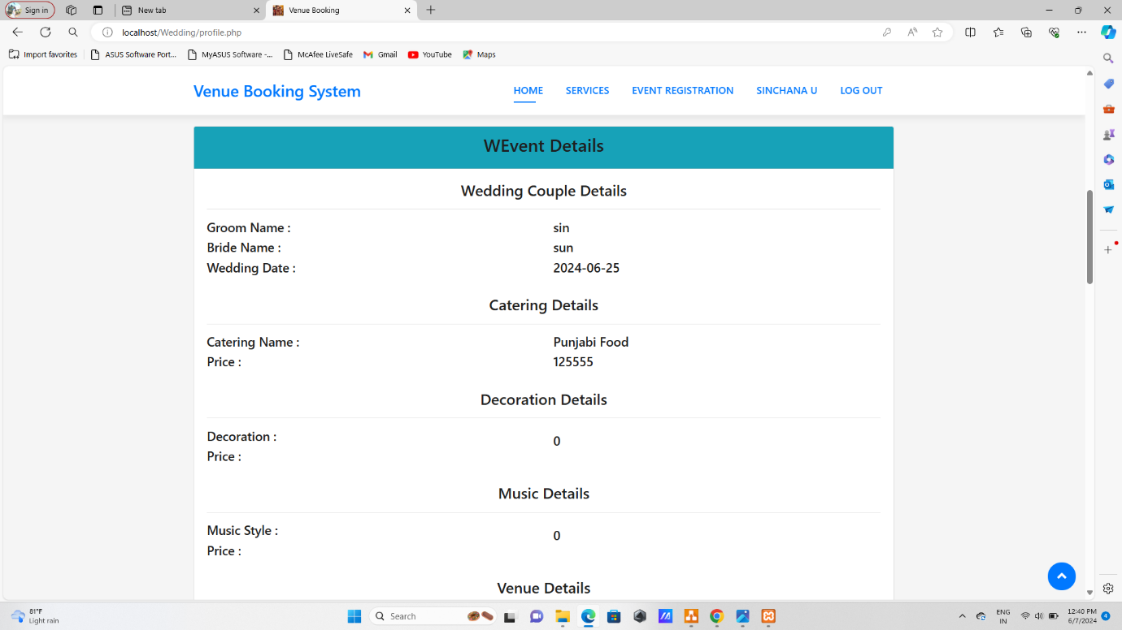

Fig 3.5

3.2.5 Contact Page

Users can contact through the given contact details.

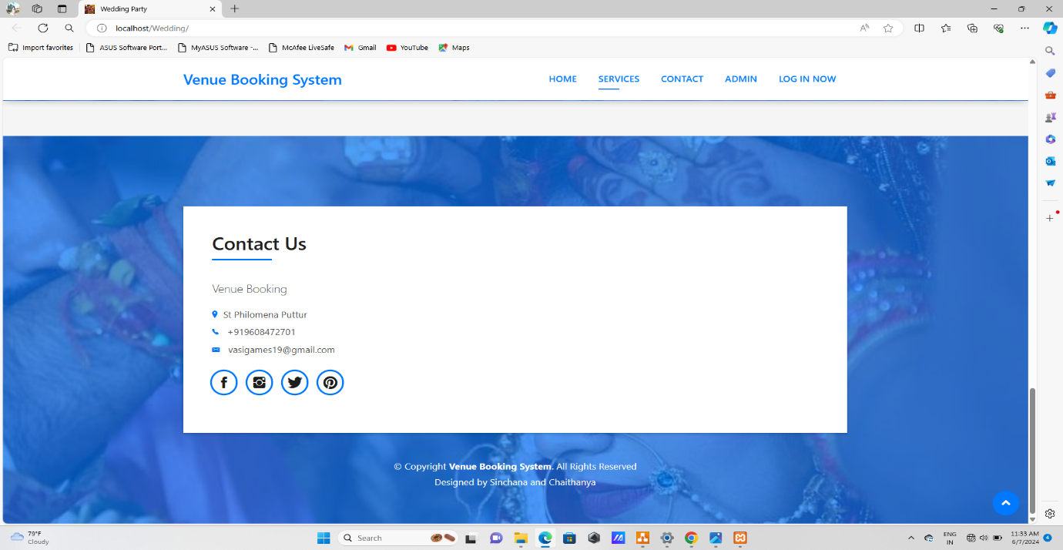

Fig 3.6

# CHAPTER-4

CONCLUSION

## 4.1 Major Findings

The development and deployment of the Venue Booking System Project yielded several significant findings that informed our understanding of user needs, system performance, and overall project effectiveness. These findings are categorized into various aspects such as user requirements, functionality, performance, security, usability, data management, technical challenges, compliance, and project management.

#### 4.1.1. User Requirements and Satisfaction

* Finding: Users, including property owners and tenants, prioritized simplicity and ease of use over a multitude of complex features.
* Impact: Adjustments were made to the user interface to enhance simplicity, resulting in higher user satisfaction and better engagement.

#### 4.1.2. Functionality and Features

* Finding: A notable demand for real-time communication features between property owners and tenants was identified.
* Impact: Development efforts were redirected to include real-time chat and messaging functionalities, enhancing user interaction and satisfaction.

#### 4.1.3. Performance and Scalability

* Finding: The system faced performance bottlenecks under high traffic, leading to slower load times.
* Impact: Performance optimization techniques such as database indexing, caching, and load balancing were implemented to ensure the system could scale efficiently with increased user load.

#### 4.1.4 Security and Privacy

* Finding: Initial security assessments revealed vulnerabilities in the authentication process, potentially exposing user data.
* Impact: Enhanced security measures, including two-factor authentication and robust encryption protocols, were integrated to safeguard user information and ensure privacy.

#### 4.1.5. Usability and Accessibility

* Finding: Usability tests showed that certain sections of the website were not easily navigable, particularly on mobile devices.
* Impact: The user interface was redesigned to be more responsive, improving accessibility and user experience on both desktop and mobile platforms.

#### 4.1.6. Feedback and Iteration

* Finding: Continuous user feedback highlighted the need for additional features, such as more detailed property descriptions and advanced search filters.
* Impact: An iterative development approach was adopted, allowing for regular updates and improvements based on user feedback, ensuring the system evolved to meet user needs effectively.

## 4.2 Conclusion

The venue booking system project effectively streamlines the process of reserving spaces, offering significant uses such as automated scheduling, real-time availability updates, and user-friendly interfaces for both administrators and clients. By reducing manual errors and double bookings, the system enhances operational efficiency and communication, making it easier for users to find and book venues while providing administrators with comprehensive tools for managing reservations and generating insightful reports. This scalable and flexible solution not only improves current venue management practices but also lays the groundwork for future enhancements like mobile app integration and advanced analytics, ensuring ongoing adaptability and user satisfaction.

## 4.3 Limitation

* Scalability issues
* Data Privacy Concerns
* Dynamic Pricing Challenges
* Technological Barriers
* Event-specific limitations

4.4 Suggestions / Recommendation

To further enhance the venue booking system, it is recommended to develop a mobile application for increased accessibility, integrate secure payment gateways, and implement advanced analytics for data-driven decision-making. Additionally, incorporating AI-driven personalized recommendations, seamless calendar synchronization, and a user feedback system will boost user satisfaction. Multi-language support, customizable booking policies, marketing tools for promotions, enhanced security measures, integrated customer support, and additional venue management features like inventory control will collectively improve the system's functionality and efficiency, making it a comprehensive solution for modern venue management needs.

#### 4.4.1. Enhance User Experience

To enhance user experience in the venue booking system, focus on creating an intuitive and responsive user interface that simplifies navigation and ensures a streamlined booking process with easy search and filter options.

* Simplified Navigation: Ensure the interface is clean and intuitive, with a clear and logical flow that allows users to find and book venues easily.
* Responsive Design: Design the system to be fully responsive, providing an optimal experience on both desktop and mobile devices.
* Easy Search and Filter Options: Provide robust search and filter functionalities so users can quickly find venues based on location, date, capacity, and other relevant criteria.
* Real-Time Availability: Display real-time availability of venues to prevent double bookings and enhance user confidence in the system.
* User Profiles: Allow users to create profiles where they can save their preferences, previous bookings, and favourite venues.
* Personalized Recommendations: Utilize machine learning to offer personalized venue recommendations based on past bookings and preferences:
* Detailed Venue Listings: Include comprehensive details for each venue, such as photos, amenities, pricing, and reviews from previous users.
* Accessibility Features: Ensure the system is accessible to users with disabilities by following best practices in web accessibility.

#### 4.4.2 Expand Features and Services

* Detailed Filters: Allow users to search based on specific criteria such as venue type, size, location, price range, amenities, and availability.
* Map Integration: Integrate a map view to help users find venues based on geographic location and proximity.
* User Dashboard: Provide a personalized dashboard where users can manage their bookings, view past reservations, and save favorite venues.
* Login via Social Media: Allow users to sign up and log in using their social media accounts for ease of access.

#### 4.4.3 Enhance Customer Support

* 24/7 Customer Support: Provide 24/7 customer support through multiple channels, including live chat, email, and phone support.
* Help center and FAQs: Develop a comprehensive help-center with frequently asked questions (FAQs), tutorials, and guides to assist users in navigating the website.

## 4.5 Learning outcomes

Developing a House Rent Management System using HTML, CSS, PHP, and MySQL offers a comprehensive learning experience that spans various aspects of web development and database management.

#### 1. Understanding Web Development Fundamentals

HTML (HyperText Markup Language):

* Gain proficiency in structuring web pages using HTML.
* Learn to create and organize content with elements like headings, paragraphs, lists, links, and forms.

CSS (Cascading Style Sheets):

* Master the ability to style and layout web pages with CSS.
* Learn to create responsive designs using media queries and flexbox/grid systems.
* Understand how to implement animations and transitions to enhance user experience.

#### 2. Server-Side Scripting with PHP

* Learn to use PHP to generate dynamic web content based on user interactions and database queries.
* Understand how to process and validate form data on the server side.
* Gain insights into maintaining user sessions and managing authentication and authorization.
* Learn techniques for error handling and debugging in PHP to ensure smooth functionality and user experience.

#### 3. Database Management with MySQL

* Acquire skills in designing relational databases to store and manage data efficiently.
* Understand normalization and how to structure tables to avoid redundancy.
* Develop proficiency in writing SQL queries to perform CRUD (Create, Read, Update, Delete) operations.
* Learn to optimize queries for better performance and scalability.
* Understand the importance of data validation, integrity constraints, and secure handling of user input to prevent SQL injection attacks.

#### 4. User Experience (UX) and User Interface (UI) Design

* Learn to create responsive web pages that provide a consistent user experience across different devices and screen sizes.
* Understand the principles of web accessibility and how to design web applications that are usable by people with disabilities.
* Gain skills in conducting usability testing to gather feedback and make data-driven design improvements.

## 4.6 Abbreviations and Acronyms

* CFD: Context Flow Diagram.
* DFD: Data Flow Diagram.
* PHP: Hypertext Preprocessor.
* HTTP: Hypertext Transfer Protocol.
* I/O: Input /Output.
* OS: Operating System.
* CSS: Cascading Style Sheet.
* ADMIN: The Administrator.
* CPU: Central Processing Unit.
* GUI: Graphical User Interface.
* RAM: Random Access Memory.
* SQL: Structured Query Language.

## 4.7 References

* Pankaj Jalote, (2004). An Integrated Approach to Software Engineering, (3rded.). Narosa Publishing House.
* D. K. K. K. Prasad. Software Testing Tools. Dreamtech Press.
* Ivan Bayross. HTML5 and CSS3 made simple. BPB Publications.
* Ivan Bayross.SQL/PL/SQL- the Programming language of Oracle (1st ed.). BPB Publications.
* Get started with Bootstrap. [https://getbootstrap.com/docs/5.3/getting-](https://getbootstrap.com/docs/5.3/getting-started/introduction) [started/introduction](https://getbootstrap.com/docs/5.3/getting-started/introduction)
* PHP Tutorial. <https://www.geeksforgeeks.org/php-tutorial/>
* CSS Tutorial. <https://www.w3schools.com/css/default.asp>
* JavaScript Tutorial. <https://www.w3schools.com/js/default.asp>
* HTML Tutorial. <https://www.w3schools.com/html/default.asp>
* [Vishweb Design]. <https://youtu.be/iNnLHlpdrao>
* [FundaOfWebIT]. [https://www.youtube.com/@FundaofWebIT](https://www.youtube.com/%40FundaofWebIT)
* [BoostMyTool]. [https://www.youtube.com/@BoostMyTool](https://www.youtube.com/%40BoostMyTool)

## 